Social Story Template Walka Water Works

# Hello Parents and Carers

# This is a social story template to help you plan and prepare your visit to Walka Water Works in Oakhampton - just outside of Maitland.

# We've included descriptions of the popular activities that many children and young adults enjoy when they visit.

# Photos are included so you don't have to visit the site in advance. Modify this template to suit your needs.

# Hats and sunscreen are necessary. It can get quite hot in summer so plan the best time to be there.

# There is a large reservoir that is isn't fenced. The water does have blue-green algae so people should not come in contact with this water.

# The main recreation area is flat and is immediately adjacent to the car parking area.

# The train that operates on the first and third Sunday of each month, has been modified to take wheel chairs.

# The walk to the model yacht club shelter is flat and can be achieved with a wheel chair. It is a fine gravel path extending alongside the reservoir. It will take 10 minutes walking or 15 by wheel chair. At the turn oﬀ to the model yacht club there are water channels and pits so do not leave children unattended.

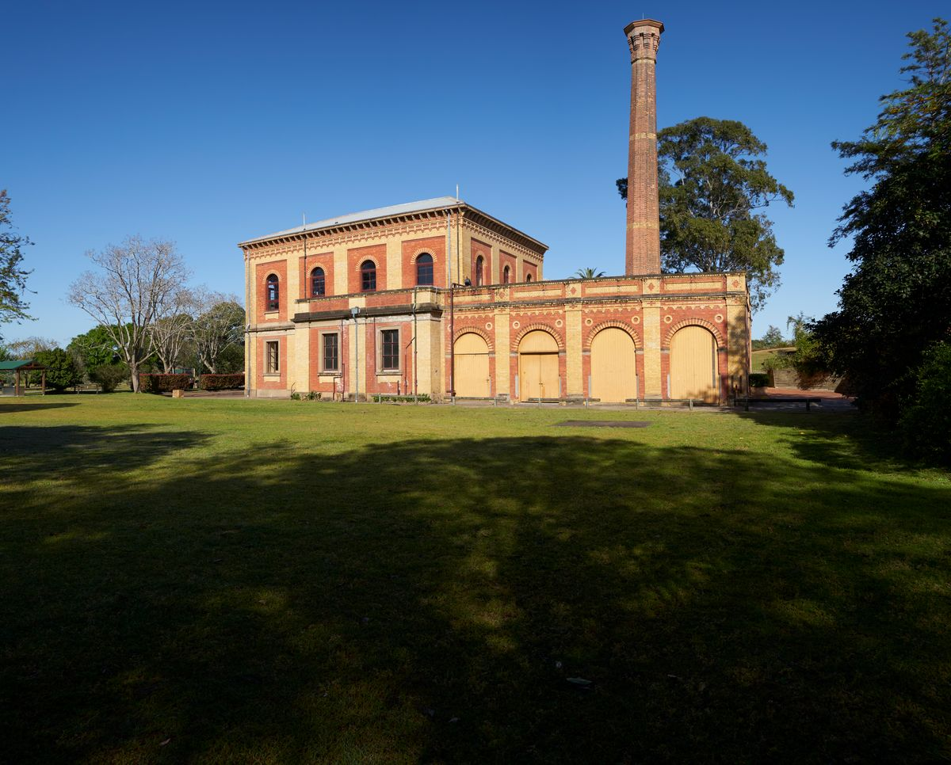

## Our Visit to Walka Water Works

# On …………………………………………………………….. we will visit Walka Water Works in Oakhampton.

# We will travel by …………………………………………. and it will take ……………………………… to travel there.

# When we arrive we will park the ……………………………………………..

# We will get out of the ……………………………………………. we will go to the grass area and wait for instructions.

# 

# *Old gate at the picnic grounds at Walka Water Works*

# It is important to listen to instructions because there is a big lake at Walka. It has lots of water. We must not walk to the lake edge unless ………………… is with me. Nobody is allowed to swim in the water.

# 

# *View from the path looking back towards the main picnic grounds and the pump house*

# The toilets are in the small brick building on the other side of the grass area on the left. *Only toilet block on site is in the main picnic area, next to main car park*

# When everybody is ready we will go to the toilet. When we have finished we will wash our hands.

# There is a playground with swings, rockers and a spider net.

# The grass area has picnic tables where we can sit. We will eat our lunch / morning tea at the picnic tables.

# 

# *Several picnic tables are available. Some are in shade under the trees.*

# On the other side of the road we see a big old two storey building. It is called the Pump House. We cannot go inside the Pump House. It is closed. Nobody can go inside.

# It worked more than 150 years ago but it is empty now.

# 

# *The original pump house building at Walka, across the road from the picnic area*

# Inside the building large steam pumps that would pump the water from the Hunter River to be stored in the lake. The water was used to provide drinking water to people in the Hunter area.

# There are some examples of old machinery in the park next to the pump house.

# *Miniature railway details a short walk from the picnic area*

# *Old machinery on display on the right side of the pump house*

# Sometimes on the first and third Sundays in the month a miniature railway operates. If it is raining it may not be running.

# We may walk to the shelter at the end of the long straight path. We will turn around and walk back to the grass area.

# 

# *Path leading to the model yacht club on a foggy morning*

# *Reservoir. The path runs on the other side of the sandstone wall*

# 

# *The model yacht club shelter at the end of the path*

# 

# *View from the model yacht club shelter looking back on the path. Picnic ground and pump house visible in the distance*